Name:
Title:
Course name:
Course code:
Professor:
Date:

International organization
Introduction
International organizations are created in order to ensure that the objectives that cannot be achieved on their own are achieved collectively. That is the main reason why states form international organizations. International organizations are useful in solving community issues such as security, poverty, human rights violation, political, gender among other issues. International organizations are used to create social order that ensures there is a clean pursuit of shared goals. It is one way states are able to come together and ensure a friendly relationship is created among the member nations. In many occasions, international organizations are used by states as a platform to interact with other nations and ensure corporation and coordination is attained in solving the community problems in existence (Rittberger, Zangl, & Kruck, 2011).
International organizations are formed and organized according to the International Law Commission. They are governed by the international law while possessing their own international legal personality. They, however, make international laws which govern them. Other entities who wish to join the organizations can apply for the same in order to secure their membership. These member states then follow the set rules in the international organization and they use the same approach to collectively solve a community issue. The memorandum of association that binds the members of the international organization contain the rules that each of the members is supposed to follow/adhere. The norms and the practices of the international culture are cultivated by the member states (Barkin, 2013).
The role of international organizations in the 21st century has always been focused on peace and security, development, human dignity, governance and environment. Top of the agenda has been the revival of nationalism, solving humanitarian crises and gross violations of human rights, looking keenly on the issue of environmental degradation, social inequalities, health, drugs and drug trafficking, human trafficking, terrorism, unemployment, population growth, global citizenship among other issues (Taylor, 2015). In the 21st century we have had the growth and development of the most functional international organizations among them WHO.
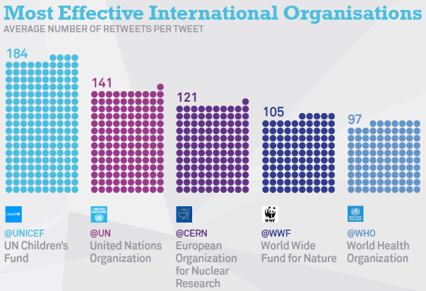
Historical overview of international organization
The international organization have its origin in the 19th century in Europe. This is as a result of developments in industrialism as well as the introduction of more developed ways of communication and transport stimulated by the public international unions. In the 1865 notable agencies crop up after the World War II. The effort to form the international organizations was to keep political boundaries by the dominant powers of Europe which were undertaken in the Congress of Vienna in 1815 (Schechter, 2016). The same concept was broadened by the Hague Conferences of 1899 as well as 1907 whose members had great powers to participate in political deliberations. The main reason for formation later changed to promote coordinated response in matters concerning institution building , economic, social as well as technical interdependence. The United Nation was conceived as the central component of international organization. The system would , however, change in 1945 allowing the international organization to function independently (Schechter, 2016).
Impacts of international organization
- Global security attained through regional cooperation
Regions have seen the importance of peace and security which promote peaceful coexistence between communities involved. This is one way that can promote economic growth in the given block.
- Economic and social challenges
International organizations have been able to largely influence economic ties that ensure development and environmental sustainability. Human rights have also been a great emphasis when it comes to humanitarian development (Taylor, 2015).
Pros and cons of the organization and effects on international cooperation
Pros
- Supporters argue that international organizations solve deep rooted problems in the society e.g. poverty and unemployment
- Helps in reducing barriers e.g. tariffs
- Promotes global economic growth
Cons
- They are seen as tools to make the rich richer and the poor poorer thus diverting their aim
- A lot of money is transferred to the least developed countries
Strengths and weaknesses in study and as practiced today
International organization have numerous strengths that gives them power to work tirelessly to develop the world in one way or the other. The most important strength that they have is monetary support that they get form governments, donors, and businesses to carry on their affairs. They are also able to secure international security and protection as they carry on with their mandate. On the part of weaknesses, the international organization sometimes face rejection from communities who don’t welcome their idea and this becomes challenging (Barkin, 2013).
Conclusion
In conclusion, international organizations have had a great impact in our society. They have selflessly fought for the rights of people worldwide, brought in economic and social development. Through international organization, sanity has been bestowed in the society which enhances peaceful co-existence between people of different races and ethnic groups across the globe.

References
Barkin, J. S. (2013). International Organization: Theories and Institutions. Basingstoke: Palgrave Macmillan.
Rittberger, V., Zangl, B., & Kruck, A. (2011). International Organization. Basingstoke: Palgrave Macmillan.
Schechter, M. G. (2016). Historical dictionary of international organizations. Lanham, Md: Scarecrow Press.
Taylor, P. G. (2015). International organization in the modern world: The regional and the global process. London: Pinter.

